1. **What is SDLC ?**

SDLC full form is Software Development Life Cycle.

Definition – SDLC is a structured imposed on the development of software testing product that defines the process of planning, testing, design, implementation, documentation, deployment, and ongoing maintenance and support.

1. **What is Software testing?**

Software testing is a process to identify the completeness, correctiveness & Quality of developed computer software.

1. **What is Agile Methodology ?**

Agile methodology is a combination of the iterative and incremental process with focus on adaptability and customer satisfaction by rapid delivery of working software.

1. **What is SRS ?**

SRS full form is Software Requirement Specification.

Definition – SRS is a complete description of the behavior of the system to be developed. It includes the use cases the describe all the interactions that the user will have with software.

1. **What is OOPS ?**

OOPS full form is Object Oriented Programming

Definition – OOP means identifying the objects and assigning responsibilities to the objects which means the objects communicate with the object by sending a message.

Black box testing, functional testing.

1. **Write basic concept of OOPS.**

The basic concept of OOPs are Object, Class, Encapsulation, Inheritance, Polymorphism, Abstraction.

1. **What is Object ?**

Is a instances of an class

:to create memory for that class to access the whole properties from the class except private

: using new keyword and class constructor to create memory for object

Sy:

Classname objectname = new classname()/constructor();

1. **What is Class ?**

An object is a collection of data member (variables) and member function (process, methods) with its behavior

Sy:

Class classname

{

Data member;

Member function;

}

1. **What is Encapsulation ?**

Data hide :wrapping up of data into single unit i.e.

:private your data member and member function

1. **What is Inheritance ?**

:Properties of parent class extends into child class

:properties of superclass extends into subclass

:main purpose is re usability, extensibility etc…

There are mainly five types

1. Single : one parent having one child only
2. Multilevel : single inheritance having one another child
3. Hierarchical : one parent having two or more child
4. Multiple : some language is not supported directly
5. Hybrid : some language is not supported directly
6. **What is Polymorphism ?**

Ability to take one name having many forms / multiple forms different forms

There are two types:

1. Compile time (method overloading):
2. Run time (method overriding):
3. **What is abstraction ?**

Only essential part should be display rest of the part will be hide.

1. **Draw Usecase on online book shopping.**

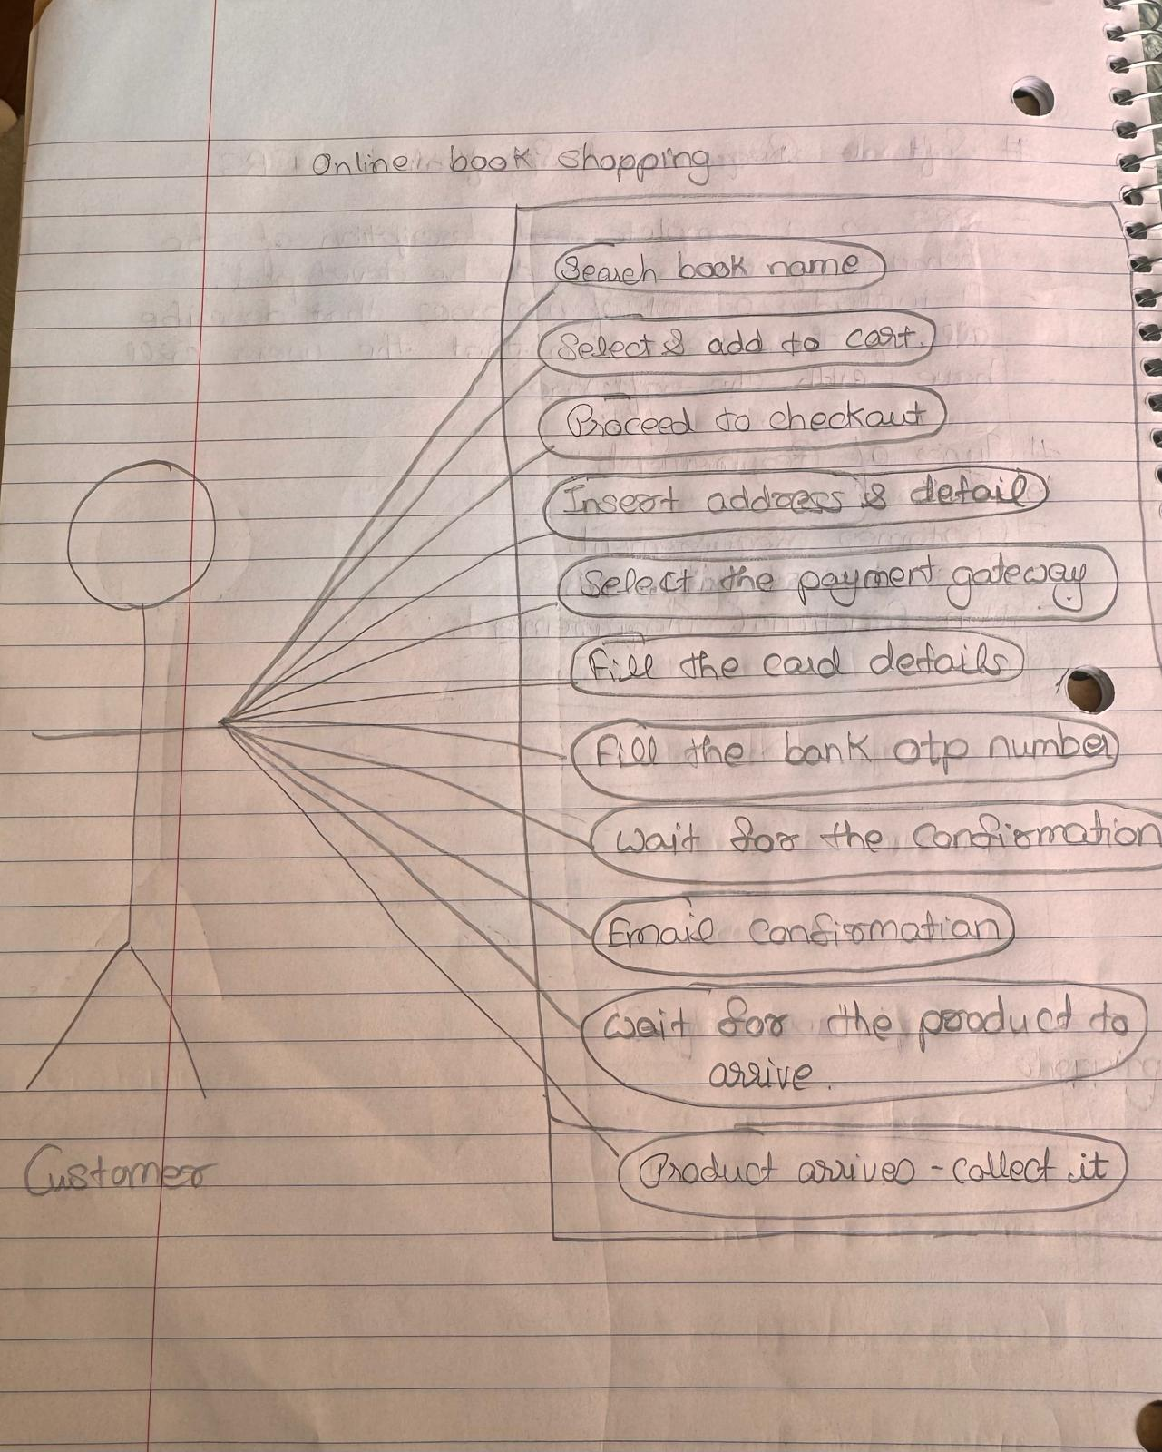

1. **Draw Usecase on online bill payment system (paytm).**

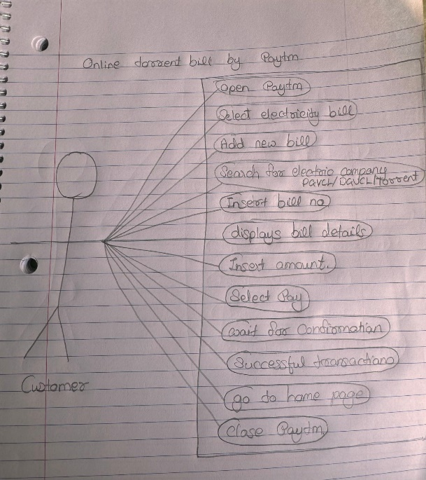

1. **Write SDLC phases with basic introduction.**

There are six SDLC phases.

1 – Requirement gathering – it’s a phase where the users/customers needs are established. In this phase three types of problems also arises that are Lack of clarity, Requirement confusion, Requirement amalgamation

2 – Analysis – this is the requirements of system, independent of how this requirements will be addressed.

3 – Design – this phase includes of design architecture document and how to plan the implementation and tests.

4 – Implementation – In this phase the team builds the design document from design phase and requirements document from the analysis phase. The product is build exactly what is asked for but with the space of innovation.

5 – Testing – as the quality of the product is very important the team test the product for the quality check.

6 – Maintenance – this phase includes the changing of a system after its deployed. There are three types of maintenance Corrective maintenance, Adaptive maintenance, Perfective maintenance.

1. **Explain phases of the waterfall model.**

The phases of the waterfall model are same as SDLC phases that are Requirement gathering, Analysis, Design, Implementation, Testing, Maintenance but the change is that this all are performed step by step in a one way phase there are no space for flexibility or changes made after or while building a system.

1. **Write phases of the Spiral model.**

The spiral model includes four phases ,

1 – Planning – this phase includes the users needs and requirements, alternatives and constraints.

2 – Risk analysis – this phase includes of identification of risks in the systems that can increase the cost or delay the project.

3 – Engineering – development of the project to the next level after the go, no go decision.

4 – Customer evaluation – this phase means the quality check by the customer of the Product.

1. **Write Agile manifesto principles.**

Agile manifesto includes four principles, 1) Individual interactions, 2) Working software, 3) Customer collaborations, 4) Responding to change.

1. **Explain working Methodology of Agile model and also write pros & cons.**

Working methodology of agile is totally based on customer satisfaction and adaptability. Agile method breaks the product into small incremental builds and provided in iterations. Each iterations works simultaneously on planning, designing, analysis, coding, unit testing, acceptance testing.

Pros – 1) promotes teamwork & cross training

2) realistic approach to software development

3) suitable for fixed or changing requirements

4) functionality can be developed rapidly and demonstrated.

Cons – 1) not suitable for complex product

2) more risk of sustainability, maintainability, extensibility.

3)Depends totally on customer interactions so if the customer is not clear the team can go on the wrong directions.

1. **Draw usecase on online shopping product using COD**

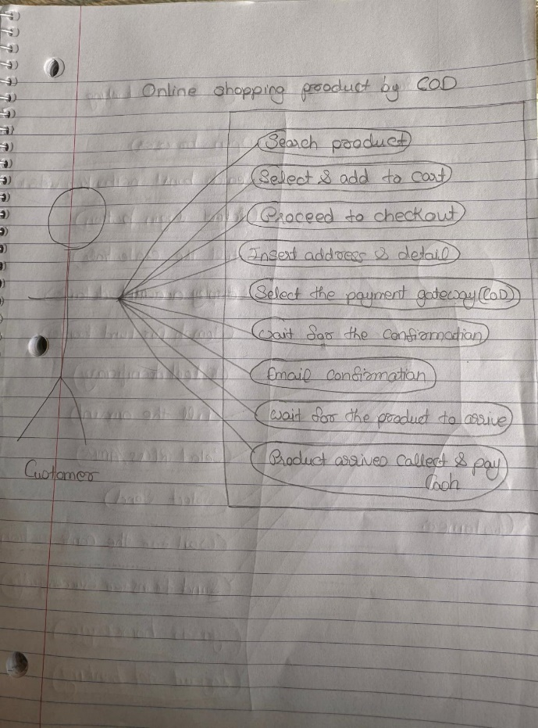

1. **Draw usecase on online shopping product using payment gateway**

